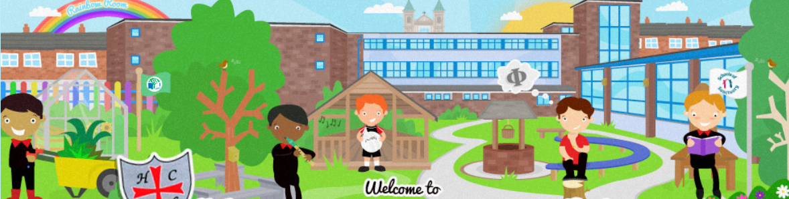
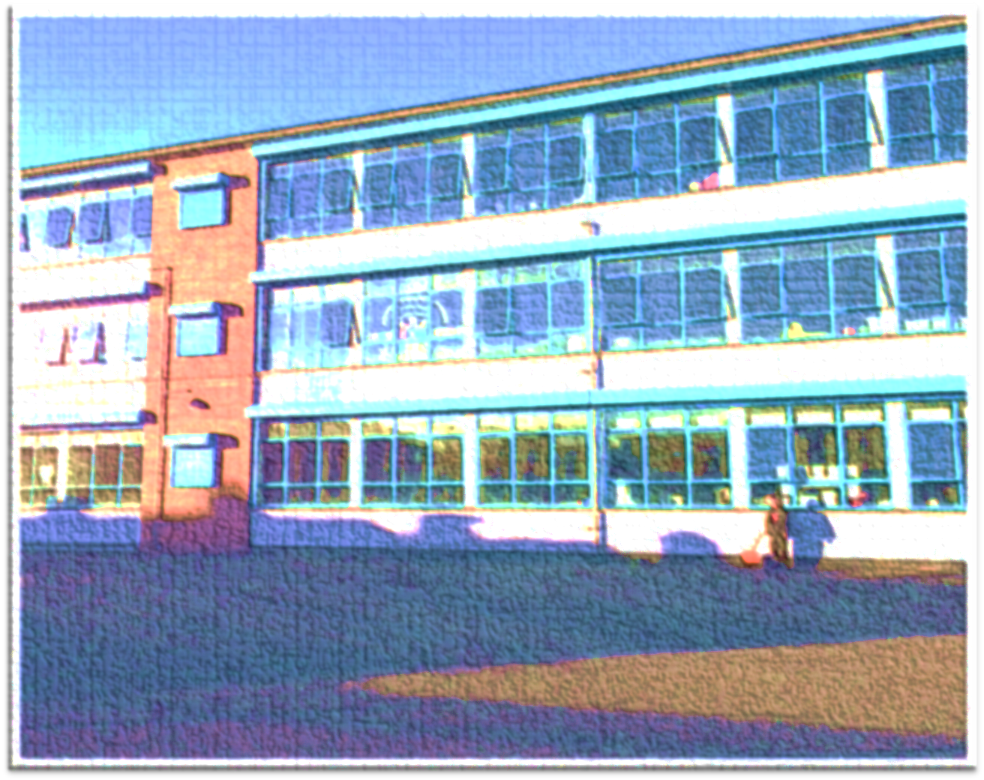
Holy Cross Boys' Primary School

Nurturing Talent & Fulfilling Potential

Information for Prospective Parents
2026 – 2027
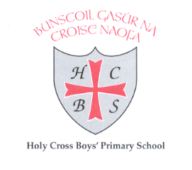

Graded an OUTSTANDING school in all areas by the ETI
“The drive for improvement in this school at all levels is continuous and unrelenting.” (ETI)

Phone: 02890-351032 holycrossboys@hotmail.com Twitter: @HolyCrossBoys FB: Holy Cross Boys’ PS www.holycrossboys.com
Holy Cross Boys’ Primary School is a Catholic Maintained Primary School

- Principal: Mr Kevin McArevey
- Vice Principal: Mr Ciaran Curran
- Chairperson of the Board of Governors: Mr. Sean Moyes
- Address: Holy Cross Boys' PS,
Brookfield Street,
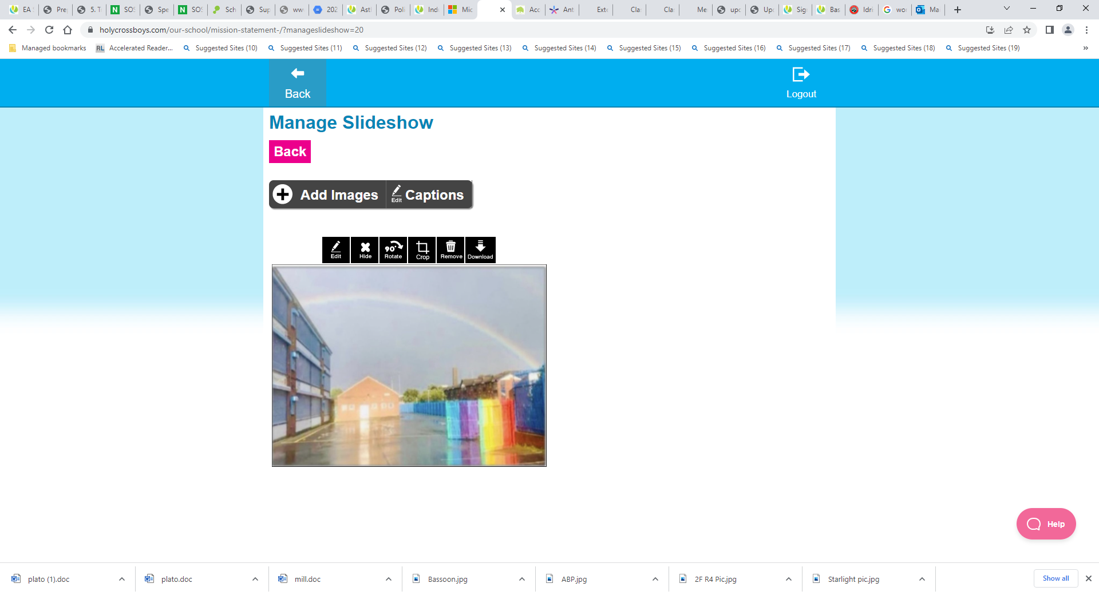
Belfast
BT14 7EX
- Telephone No: 028 9035 1032
- Email: holycrossboys@hotmail.com
- Website: www.holycrossboys.com

Twitter: @HolyCrossBoys
Holy Cross Boys’ PS

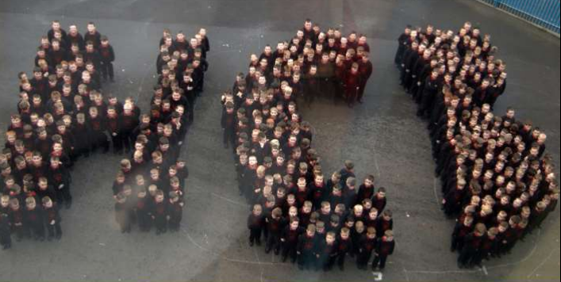

A message from the principal - Mr Kevin McArevey
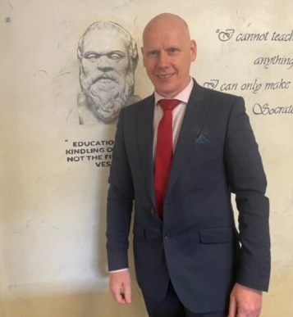
As the Principal of Holy Cross Boys’ PS, I extend a very warm welcome to you and your children.
Our School Prospectus aims to give you a flavour of the pastoral, academic, musical and sporting success that the pupils in our school can experience. We wish every child in our care to have special and happy reflective memories of their time with us.
We want all our children to develop a love of learning that remains with them for life. We also want them to develop the values and skills they will need to succeed in and contribute to, the diverse world in which they live.
As a Catholic school we aim to educate children to the highest standards and develop their relationship with Jesus Christ, reflected in the spirit and interactions within the school.
Holy Cross Boys’ has an outstanding reputation for academic success, music, sports, languages and Philosophy. We aim to recognise and nurture the talents in all, so that the children may reach their full potential.
It is our partnership with parents which allows us to continue to improve and maintain our high standards of learning and behaviour. The whole community takes pride in our school’s focus on rights for children which help us promote equality, tolerance and respect for all.
There is a well-established breakfast club and after school clubs, which support families with childcare from 8am until 4pm. We are building an excellent and inclusive school community where children are proud of their achievements and excel in their learning.
Thank you for taking the time to navigate our website.
Is mise le meas,
Kevin Mc Arevey
Principal
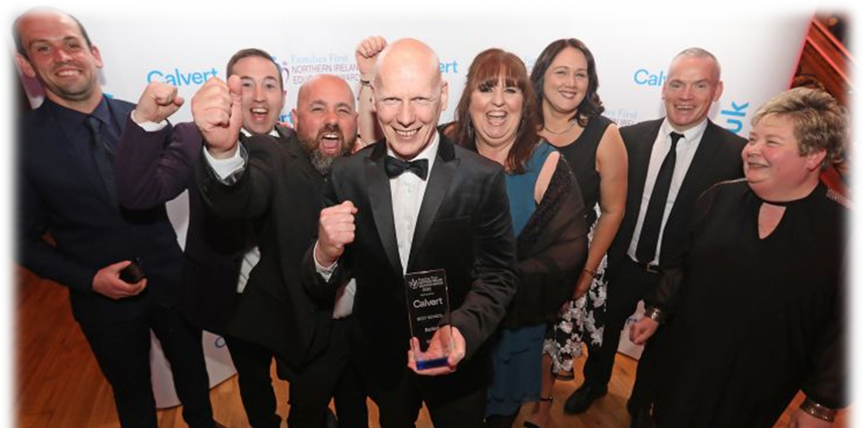

Meet our Board of Governors
A message from the Chair of the Board of Governors - Mr Sean Moyes
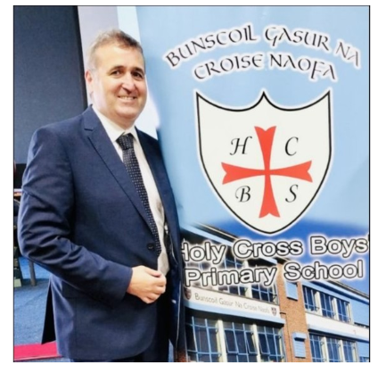
The fundamental requirement of all governors is to ensure that the school works hard to achieve the highest standards of teaching and learning, in order to maximise the educational progress of every pupil and that every child flourishes within a caring and stimulating learning environment. In Holy Cross Boys’ the governors are invited into the school regularly to view good practice and are delighted to report the hard work ethos, commitment and dedication of the staff is evidential in all classrooms.
Our main focus is to ensure the school has a clear vision, ethos and strategic direction. The principal is held to account for the educational performance of our school. As Governors, we exercise our responsibilities and powers in partnership with the principal and staff. We do not make day to day decisions on the operational running of the school, instead we support and challenge the school’s leadership team to maintain the school ethos and vision and promote self-evaluation to drive and sustain school improvement. Our governors have a variety of skills and experiences that provide the school with a wide range of expertise and support. We are expected to take part in regular training to develop and increase our effectiveness. We are unified in our commitment to the schools’ vision, “Nurturing Talent and Fulfilling Potential”.

NAME | ROLE
Mr Sean Moyes | Chairperson
Mr Kevin McArevey | Principal
Fr. Charlie Cross | Trustee and Vice Chair
Joe McNeill | Trustee Representative
Brian McKee | Trustee Representative
Darragh Lee | Trustee Representative & Secretary
Geraldine Prenter | EA Representative/ Child Protection
Mrs Orla Brooks | Teacher Representative
Karen McIlkenny | Parent Elected Representative
Sean Devine | DENI Representative
Holy Cross Boys’ Primary School Uniform Code
Pupils enrolled in Holy Cross Boys’ Primary School are required to wear the school uniform.
At HCB we expect a full school uniform to be worn at all times.
The uniform consists of:
HCB School Uniform | P.E Uniform
- Black jumper (with school crest)  - Red Polo shirt  - Plain Black trousers  - Plain black shoes/black trainers (no stripes/designs)  - Black shorts can be worn in the summer months.  - Parents/guardians are asked to label all items of clothing clearly with their child’s name.  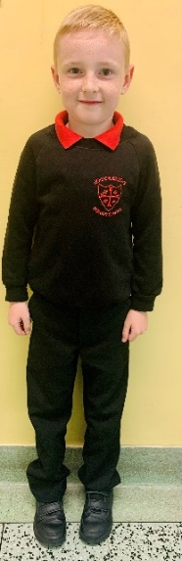  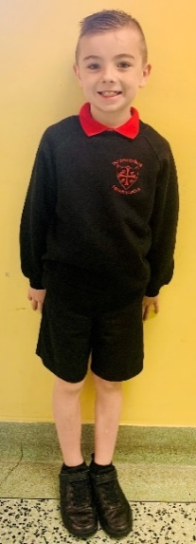  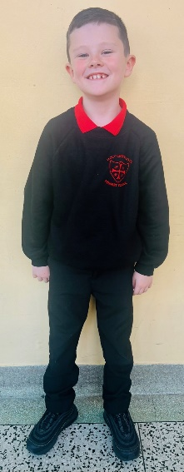  - On health and safety grounds, we do not allow children to wear jewellery in school (watches are not considered items of jewellery and may be worn). Earrings ARE NOT PERMITTED.  - Hair: Lines or dyes ARE NOT PERMITTED. | All pupils should wear their full P.E Uniform on their P.E days.  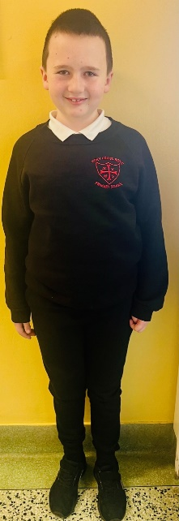  Your son can come to school for the day/s he has PE in the following:  - Black Jogger Bottoms  - White Polo Shirt  - Normal Black School Jumper with HCB Crest  - Black Trainers  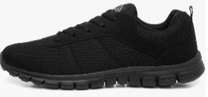  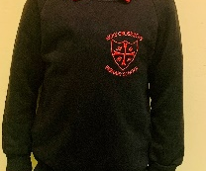  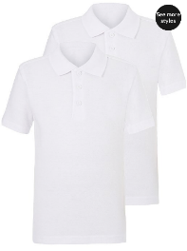  
Attendance
Holy Cross Boys’ PS is committed to a positive policy of encouraging pupils to attend school regularly. The school will work with parents, pupils and outside agencies to secure this aim.
Rewarding Pupils with Excellent and Improved Attendance
Pupils who attend School for 5 days of the week will automatically receive a Written Homework Pass for the following Thursday night. Our Student Council brought in this initiative, and it has helped to encourage improved attendance for many pupils. We also celebrate all our pupils who put in a great effort with attendance at every opportunity throughout the school year. We reward these pupils at the mid and end of each term with prizes.
ADMISSIONS CRITERIA FOR SEPTEMBER 2026
The following criteria will be applied in the order set down by the Board of Governors of Holy Cross Boys’ Primary School in selecting boys for admission in September 2026.
- Boys who normally reside in the parish of Holy Cross Ardoyne.
- Boys who have brothers or half-brothers presently at Holy Cross Boys’ Primary School. (Indicate name and year group).
- Boys from other areas.
In the event of over subscription in any one of the above criteria, taken in order, final selection will be on the basis of closeness of the home to the school (in a straight line) as measured by an Ordnance Survey Map from the gate of Holy Cross Boys’ Primary School to the front door of the applicant’s normal residence.
In the event of two or more children’s permanent residence being measured equal distance for the final place, children will be selected by lot.
When considering which children should be selected for admission, the Board of Governors will only take into account information which is detailed on or attached to the application. Parents should therefore ensure that all information pertaining to their child and relevant to the school’s admissions criteria is stated on the application or attached to it. Examples of such information include whether the child has brothers/half-brothers attending the school.
Should a vacancy arise after Monday, 23 March 2026 all applications for admission to P1, that were initially refused, new applications, late applications and applications where new information has been provided will be treated equally and the published criteria applied. This waiting list will be in place until 30th June 2026.
The school will contact you in writing if your child gains a place in the school by this method.

Duty to Verify
The Board of Governors reserves the right to require such supplementary evidence as it may determine to support or verify information on any applicant’s application.
 | No of applications received | No of pupils admitted
2011 | 69 | 69
2012 | 70 | 70
2013 | 80 | 80
2014 | 64 | 60
2015 | 59 | 59
2016 | 73 | 60
2017 | 47 | 47
2018 | 65 | 60
2019 | 62 | 60
2020 | 84 | 60
2021 | 85 | 58
2022 | 54 | 54
2023 | 54 | 52
2024 | 41 | 44
2025 | 55 | 51

If the requested evidence is not provided to the Board of Governors by the deadline given, this will result in the withdrawal of an offer of a place. Similarly, if information is supplied which appears to be false or misleading in any material way, the offer of a place will be withdrawn.

VISION
‘Holy Cross Boys’ strives to promote high self-esteem, a love of life-long learning and responsible citizenship within our school community where everyone is valued.’
The school community of Holy Cross Boys’ Primary School strives to live up to the mission and ethos of the school by the policies and practices informing the actions of staff. We actively promote Catholic values throughout the school.
The Pastoral Care policy directs the action of every member of the school to act in a manner promoting the sense of self-esteem and self-respect of pupils and this is underlined by the promotion of positive behaviour throughout the school’s merit system.
The emphasis on developing strong bonds established within the local community has helped nurture a culture of active participation within the school environment beneficial to the morale of all sections of the school community.

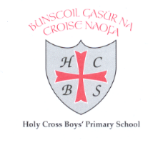
Nurturing Talent, Fulfilling Potential

MISSION STATEMENT

At Holy Cross Boys’ Primary School we aim to create a calm and caring community where teachers teach and children learn.
Each child will be encouraged to fulfil his intellectual, spiritual, physical, social, aesthetic and emotional potential. Central to the creation of this environment is a commitment of Christian values, the recognition of the worth and the value of each child and the cultivation of self-respect, so that the child may accept his appropriate responsibilities and show respect for others.
At Holy Cross Boys’ we aim to establish a community wherein pupils, teachers, parents and support staff enjoy a sense of belonging and have an important role to play.
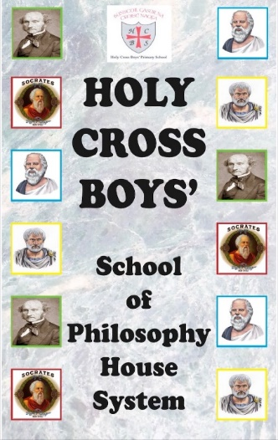
THE SCHOOL OF PHILOSOPHY HOUSE SYSTEM
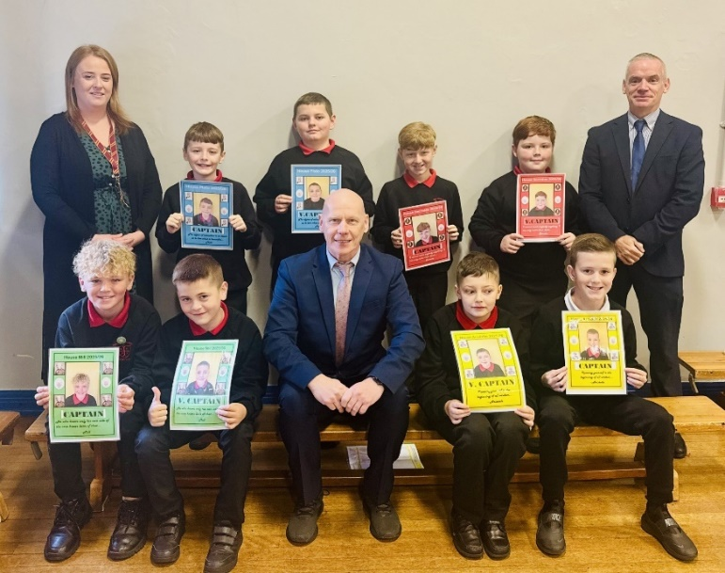
Holy Cross Boys’ Primary School has experienced excellent improvements in the promotion of positive discipline within the school community in recent years and this has been aided with the House System.
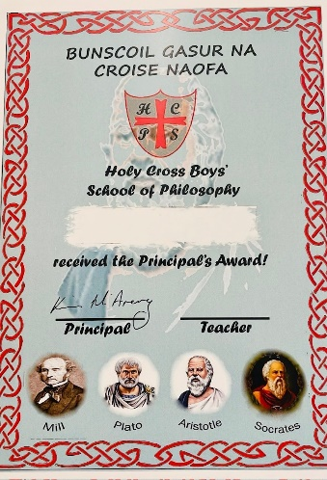
The House System incorporates 4 Philosophers, named after the big Greek three and an English Philosopher. These are House Socrates, House Plato, House Aristotle and House Mill (named after John Stuart Mill because our new house names replaced our old house names which were named after our local Mills). The boys are keen to impress their teachers and their teammates in the hope of collecting the winning House prize at the end of each half term.
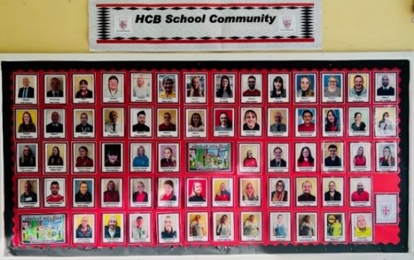
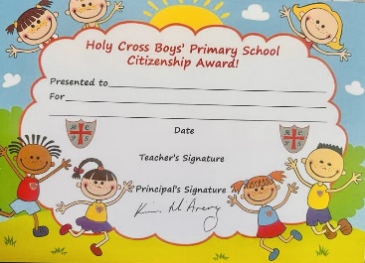
“We always try to ensure that the children have a positive experience here at Holy Cross Boys’ Primary School where everyone displays good manners and shows respect for each other,” said House Co-ordinator, Mrs Wallace. She added, “Parents can help by showing a good interest in how their child’s house is doing and how their child is scoring on the class chart. Also, if a child receives the weekly Principal Award at school, it would be great if parents could reward him at home.”
Teacher’s Award and ‘Citizenship Award’
In Primary 1 – Primary 3, the children receive a ‘Teacher’s Award’ and a ‘Citizenship Award’ which is presented each week to two children from each class. Mr McArevey visits the classes each Monday to congratulate the pupils on their awards and there is a board in the foyer where their certificates and photos are placed for all teachers, children and visitors to see.
DISCIPLINE Our School Discipline Policy is based on the school’s Christian values and beliefs.
We aim:
- To provide a supportive environment which will foster the growth and development of caring and responsible pupils.
- To create a well-ordered school in which pupils can learn effectively.
- To this end we have rules for our pupils, which we will implement fairly and consistently.
- Should the need for a pupil suspension or expulsion arise, we shall follow the procedures laid down in our School Discipline Policy.
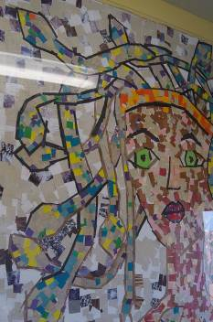
Art and Design
AREAS OF LEARNING

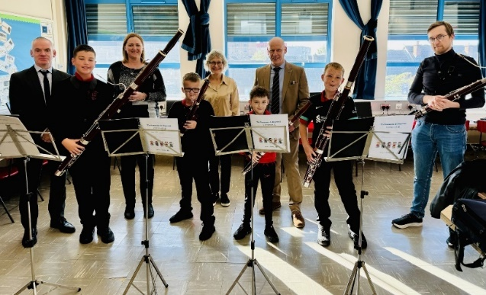
At Holy Cross Boys’ Primary School, we place a particular emphasis on the children learning and celebrating the Arts in all its dimensions.
Art and Design contributes to the development of the whole child emotionally, aesthetically, spiritually, intellectually and socially. It creates in the child a sense of enjoyment and a sense of purpose. It provides pupils with a unique way of perceiving themselves and the world, which is not taught in other areas of the curriculum, and which is essential to basic education. Children’s success in Art is acknowledged and celebrated appropriately in Holy Cross Boys’ through display in classrooms and around school.
Music
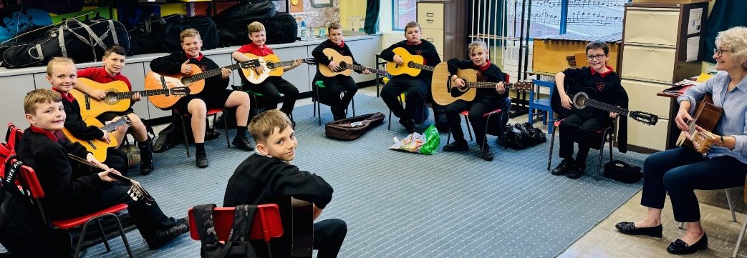
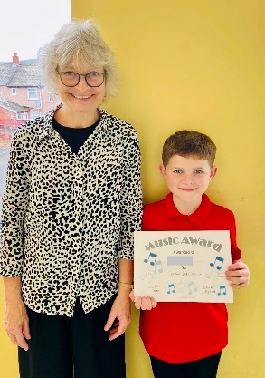
The aim of music in our school is to develop each pupil’s musical ability and encourage each child to realise his musical potential. A sense of enjoyment will be fostered, along with the development of social skills and confidence in their music- making.
By engaging in musical activity, pupils should develop a range of concepts, attitudes and skills which constitute musical thought and behaviour. Through music, pupils should also develop social skills, self-motivation and self-confidence.
Within the school, Music is taught to all classes by Mrs Martin, a music specialist. Each class receives music lessons on a weekly basis, as well as Key Stage Singing Practice in the hall. In addition, P5, P6 and P7 pupils also receive extra tuition to help them learn how to play the tin whistle.
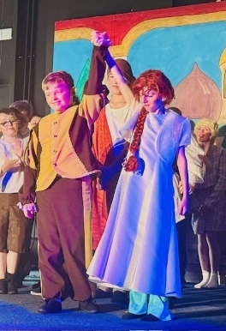
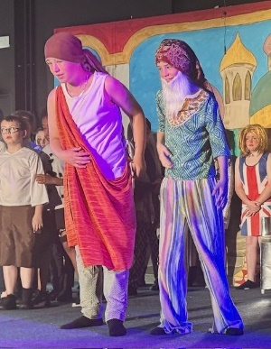
As well as the essential elements of music education- listening, composing and performing- the school also develops the pupils’ performing skills in preparing for the Religious Sacraments throughout the year (e.g. Sacrament of Penance, First Communion and Confirmation) and our Year 7 School Show. The school offers tuition on violin, flute, trumpet, bassoon, cello, vocal studies, guitar, and Djembe African drum) to pupils in Key Stage 2 and there are regular group activities for string, woodwind and brass ensemble, traditional music and choir.
Mrs Martin has also received the prestigious Classic FM’s ‘Primary School Music Teacher Of The Year’ award. She organises and enters Holy Cross Boys’ school choirs into competitions, providing our boys with the opportunity to perform in many venues, including The National Concert Hall in Dublin.
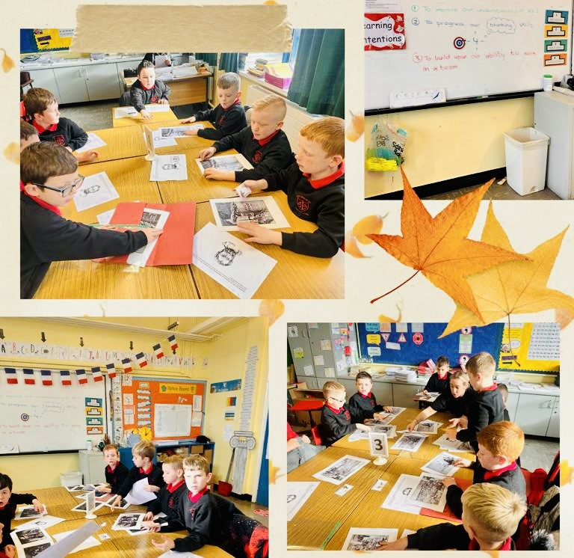
Communication
Rationale
We at Holy Cross Boys’ believe that Communication is a life-long process. It is concerned with the development, use, shaping, refining and enjoyment of language – spoken, heard, written and read. We therefore see and take opportunities throughout the day for developing communications in children, both formally and informally.
Aims
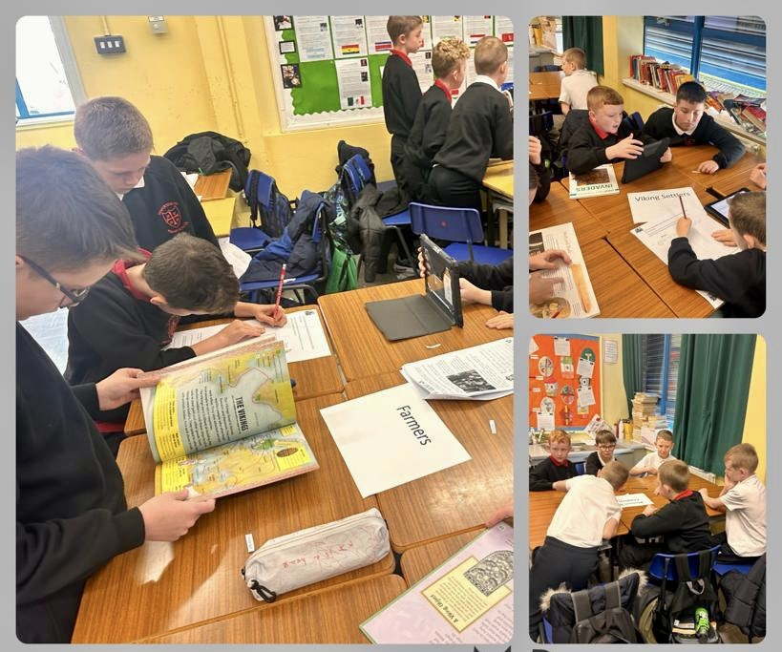
Through Communication our aim is to develop the children’s knowledge and understanding, concepts and skills in all four modes of language: talking, listening, reading and writing. In doing so, we will enable children to interact effectively in the world around them, to express themselves creatively and to communicate confidently.
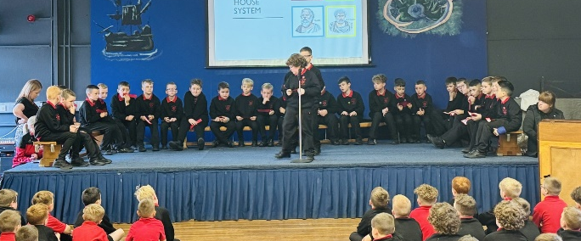
Through each of the attainment targets, teachers are instructed to vary questioning for their pupils using the Bloom’s Taxonomy model to achieve a higher level of understanding of their work. This philosophy is expected through oracy and written work so that pupils are exposed to low and high cognitive questioning so that they know not only how to reproduce work but also to provide reasons through judgements and creative responses. The school has been subscribing to the very successful Accelerated Reader Programme to try and improve reading efforts and ability of the pupils. This is a valued resource and has produced fantastic results in reading attainment while also making it fun and rewarding for the pupils.
Practice
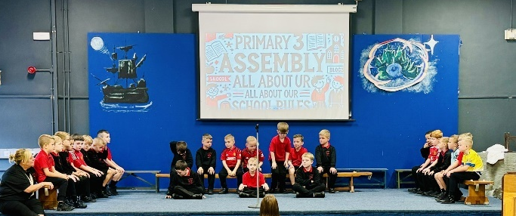
We ensure the children have numerous platforms to experience and put their skills into practice throughout the school year. All classes perform a class assembly every year and take part in Singing Practice every week. Primary 1- Primary 3 and Primary 7 children perform in a production every year where every child has a part on or backstage. The Book Fair is always a great success during the school year. The children are treated to some stories read by the Principal, Vice Principal and SENCo. There are competitions during this week for the best bookmark and fun homework related to the fair.
Philosophy
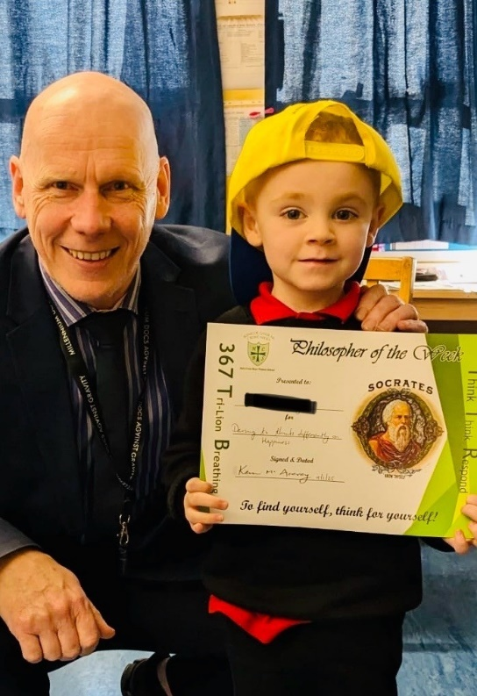
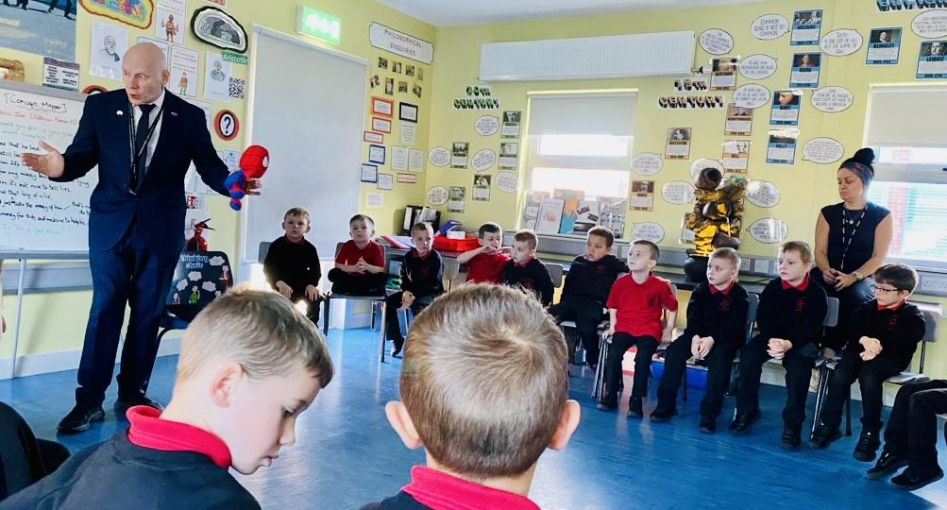
Philosophy is taught from primary 1 to primary 7. Children are taught to reflect, reason, respond and re-evaluate in a caring, collaborative, creative and critical way. All members of staff are trained by The Philosophy Foundation. We believe that one hour of philosophy education per week effectively promotes emotional and social development as well as increasing cognitive ability, critical reasoning and dialogue skills. Philosophy is embedded, infused and permeates our entire curriculum.

World Philosophy Day
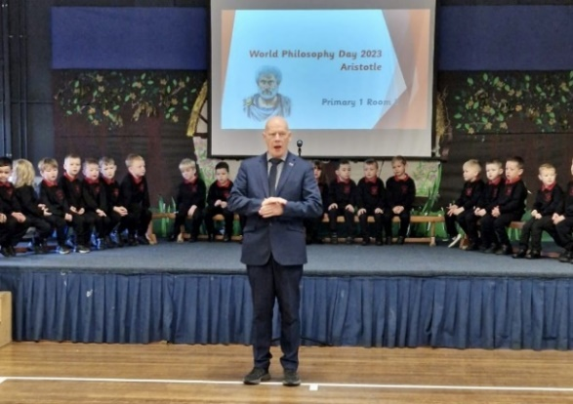
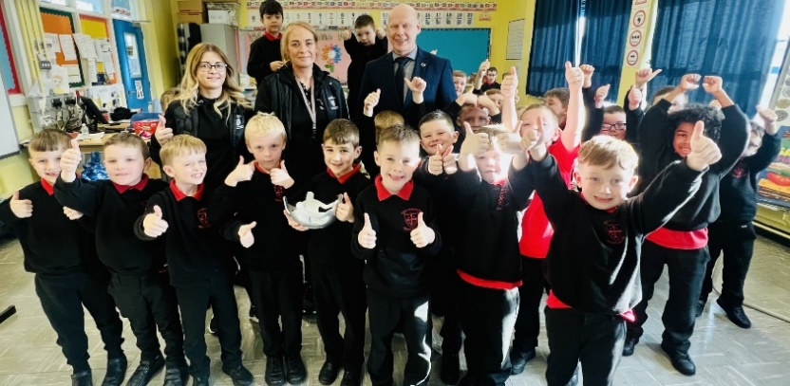
HCB celebrates World Philosophy Day in November every year with the P1-7 classes producing superb presentations on the life of famous Greek Philosophers, including Aristotle, Plato and Socrates. The winning class for 2023 was P3 (Mrs McShane) and they collected the inaugural Philosophy Bowl for their impressive performance on Aristotle and his philosophy on happiness! The beautiful bowl was donated to the school by Gillian Graham, having been inspired by our film Young Plato. The stunning bowl shows children holding hands together in unity and support.
MATHEMATICS
In Holy Cross Boys’ PS, we value every pupil and the contribution they make. As a result, children are central to this subject and should achieve success, which will enable them to develop their skills in accordance with their level of ability. We aim to equip our children with the necessary life skills to allow them to participate fully in the society in which they live.
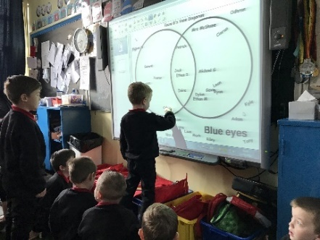
In Holy Cross Boys’ PS, our Using Mathematics Policy reflects a practice which strives to develop mathematical skills alongside the knowledge and understanding of Maths facts across the breadth of attainment target areas consistent with the requirements of the revised curriculum and new Levels of Progression.
Why we teach Mathematics/ Numeracy?
Mathematics…
- provides a way of viewing and making sense of the world;
- is used to analyse and communicate information and ideas;
- addresses practical tasks and real life problems;
- explores new ideas;
- is predictive, not merely descriptive or explanatory;
- is enjoyable and valuable as a subject in its own right and across the curriculum;
- helps children work co-operatively and independently;
- is an integral part of learning and is necessary for full participation in all aspects of the curriculum and is reinforced through other subjects;
Learning/ Teacher Strategies
In order to develop our pupils Mathematics/ Numeracy skills, it is important that our pupils meet a range of experiences including: Investigations; Problem Solving; Recording; Discussions; Games; Practical learning experiences; Use of apparatus; Structured play; ICT; Mental Maths; Employment of good questioning techniques and thinking skills and Environmental Maths.
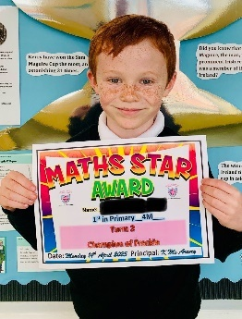
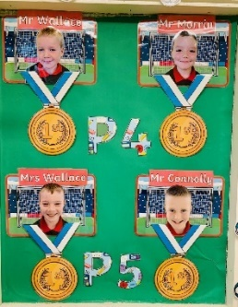
Pupils should firstly be given opportunities to encounter concrete experiences before progressing to written tasks. Practical sessions must be well planned and concepts consolidated through the employment of well-planned questioning. Teachers will strive to promote accelerated learning techniques in all lessons through practical activities, ICT, games etc.
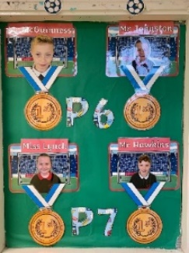
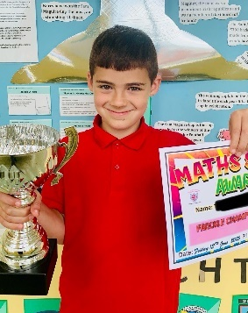
Pupils complete termly activities emphasising the real-life dimension of Maths through our Using and Applying Maths and Functional Maths schemes of work, as well as making use of the thermoplastic playground markings to explore maths in a fun-filled way. The pupil efforts are reinforced and promoted through the computer-based platform for maths, Freckle. Though Freckle we aim to improve the boys, confidence, proficiency and develop their skills in maths. The programme is personalised to help with engagement and to boost skills on an individual level.
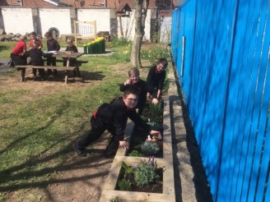
WORLD AROUND US
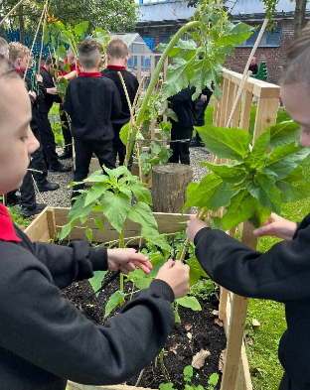
The World Around Us is one of the six Areas of Learning in the Northern Ireland Curriculum. It focuses on the development of knowledge, skills and understanding in Geography, History, Science and Technology. Holy Cross Boys’ P.S. aims to retain the best of current practice within the three subjects, while developing a topic/theme based approach to this area of learning, and making relevant connections across all areas of learning, while ensuring breadth and balance.
Aims:
- To develop knowledge, understanding and skills in the context of the World Around Us.
- To promote understanding, respect and appreciation for the world in which they live and their immediate environment.
- To acknowledge and appreciate a sense of the past, changes which have occurred and how these affect the world today.
- To develop an appreciation of the relevance and importance of Science and Technology in everyday life.
- To develop in children the skills of enquiry, investigation, analysis, evaluation and presentation.
‘At the heart of the curriculum lies an explicit emphasis on the development of skills and capabilities for life-long learning and for operating effectively in society. Through opportunities to engage in active learning contexts . . . children should develop Cross- Curricular Skills (in Communication, Using Mathematics and Using ICT) and Thinking Skills and Personal Capabilities’ – NI Curriculum
At Holy Cross Boys’ P.S., we also develop Geography, History and Science skills through the World Around Us. While many of the skills will be developed incidentally, we also plan for the development of subject specific skills when appropriate.
Personal Development and Mutual Understanding (PDMU)
Every aspect of a child’s experience at home, school and as members of their community contribute to Personal Development and Mutual Understanding (PDMU). Children are greatly influenced by society’s values; the values held by their peers, the values which are communicated explicitly or implicitly in school, and by the values of the home. Maintaining a close partnership with parents is fundamental to the task of promoting P.D.M.U. Values such as honesty, justice, fairness and respect for self and others always remain at the forefront of all teaching and learning in Holy Cross Boys’ Primary School.
At Holy Cross Boys’ Primary School, we will endeavour to enhance and consolidate the personal and social development of each child and thus enable him to become a confident person and a valuable member of his community and the wider world. Our aims are to develop the self-worth and confidence of each child in the school. We want children to appreciate that other children have worth, rights and needs. We strive to develop life skills which enable children to participate effectively and safely in society. We want children to identify, review and evaluate the values they and society hold so that they can take increasing responsibility for their own lives.
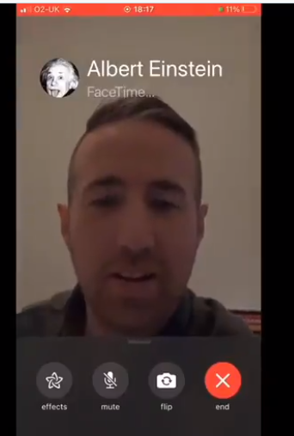
ICT
Our school vision for ICT is parallel to that of the vision for the school as a whole. ICT can be a tool to enable children to access information they don’t know and to present information they do know. Our hope is that they will be able to do both of these things in a variety of imaginative and interesting ways.
Teachers should see ICT as a tool for engaging and motivating children, making lessons interesting and making administrative tasks easy.
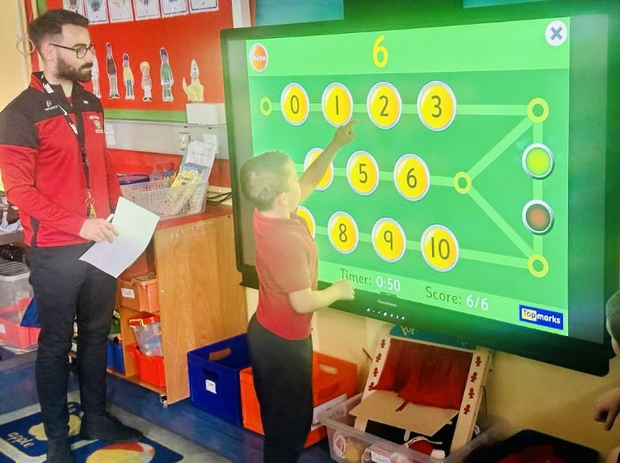
ICT can give children a future where they become responsible for their own learning, teachers and parents become facilitators. Families can learn together, multiple generations discovering communally.
We wish to provide all stakeholders in our community with the skills to move into the future and take control of their education in preparation for the ‘life-long learning’ we envision at Holy Cross Boys’.
Holy Cross Boys’ PS boasts a computer suite, which is a traditional C2k Suite where children are taught the cross curricular skill of ICT, carry out their online assessments and complete their CCEA portfolio for end of KS assessments.
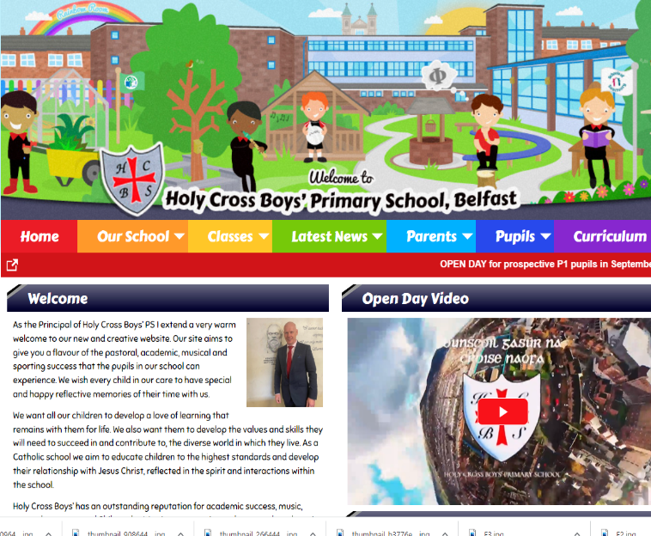
We are a multi-award-winning school, being the proud recipients of the NAACE ICT Award & the Third Millennium Teaching Award for ICT.
All of our classrooms have a Smart Interactive Whiteboard, and we ensure the 100+ iPads we currently have, can be used to maximum effect on teaching and learning. We also offer Parent & Community iPad classes to help families extend their child’s learning from school to home through the use of an iPad.

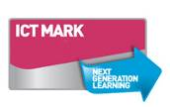
ICT has not only enhanced and motivated the children in traditional areas of the curriculum such as Literacy and Maths, but the pupils also enjoy the ‘Virtual Coach’ during PE time (Cyber Sports) in the hall where they learn various dances from the coach on the large screen. This screen also allows; assemblies, singing practices, talks, sacraments, World Philosophy Day and celebrations held in the hall to come to life. The school website www.holycrossboys.com is maintained by the ICT Co-ordinator, Mrs Mohan. All current events, holidays and news from the school can be accessed through the website.
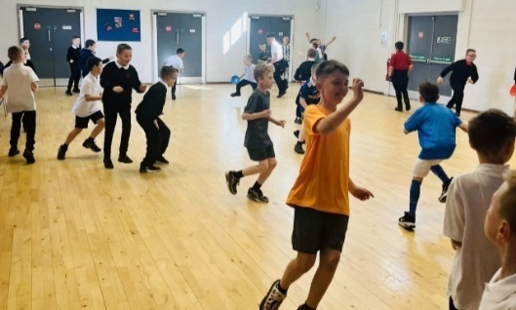
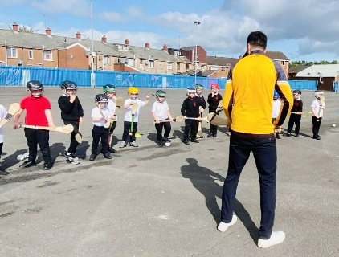
PHYSICAL EDUCATION
The school believes that physical education, experienced in a safe and supportive environment, is vital and unique in its contribution to a pupil’s physical and emotional development and health. The physical education curriculum aims to provide for pupils’ increasing self- confidence through an ability to manage themselves successfully in a variety of situations.
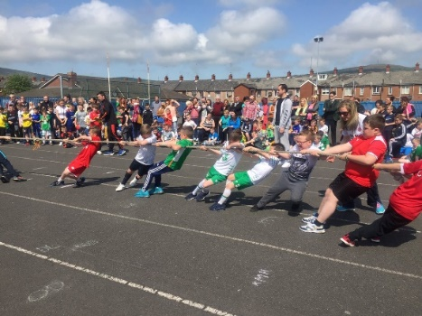
A balance of individual, team, co-operative and competitive activities aims to cater for individual pupil’s needs and abilities. The scheme of work is based on progressive learning objectives which, combined with varied and flexible teaching styles, endeavour to provide appropriate, stimulating, challenging and enjoyable learning situations for all pupils.
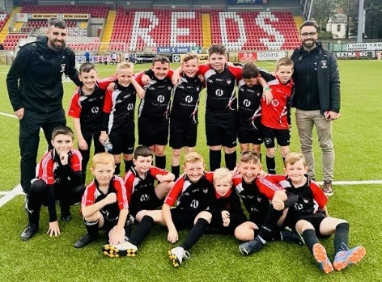
Physical education is considered as a vehicle to facilitate access to cross-curricular themes, skills and dimensions, rather than a subject concerned exclusively with the acquisition of motor skills and techniques.
Our Physical Education Programme
Our PE programme is a broad and balanced one, which provides opportunities for all our pupils to participate in a non-competitive, fun- based manner. We cater for all five areas of the PE curriculum, Games, Dance, Gymnastics, Athletics and Swimming (P5, 6 & 7) so that our pupils can draw from a wide range of experiences throughout their seven years at the school.
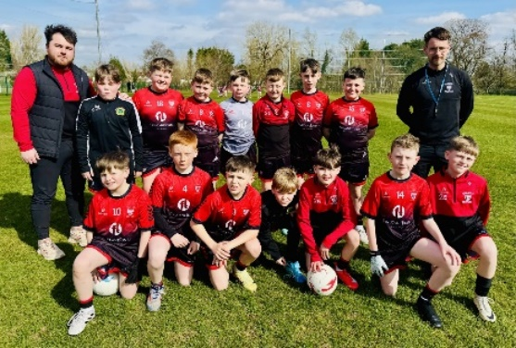
School Sports Day
Two days in the last term are devoted to Sports Day. Emphasis is placed on the participation of all pupils. Parents are invited to come and support their child in the events they are participating in. During the afternoon we have a traditional match between the teachers and the leaving Primary 7 pupils which the whole school enjoy watching.
School Teams
We at Holy Cross Boys’ take great pride in our teams and their accomplishments. We have an unparalleled reputation for success on the football field at Belfast level, and we are very supportive and proud of the endeavours of all our boys who represent the school in sporting competitions from across a broad range of disciplines including soccer, Gaelic football, handball, table tennis and athletics.
RELIGION
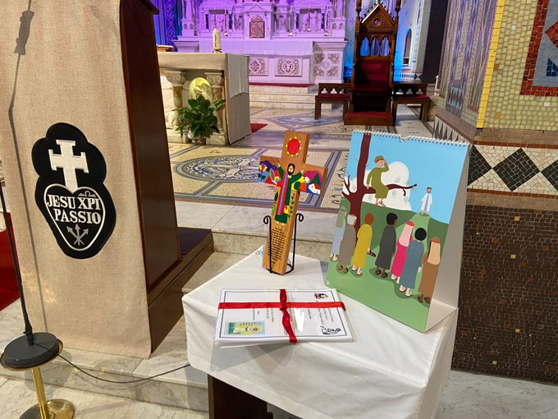
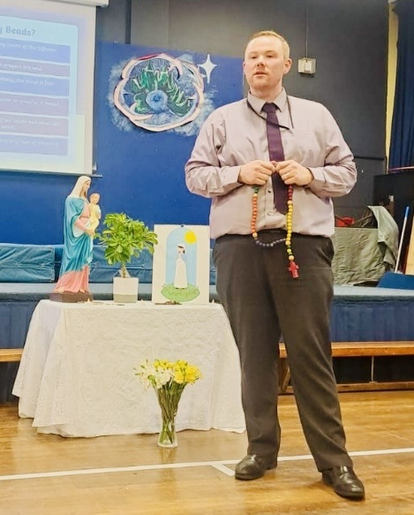
Holy Cross Boys’ is a Catholic school where our overall aim is to foster in each child a love of God and a Christian approach to life. The school is committed to the holistic development of each pupil particularly those who are disadvantaged or marginalized.
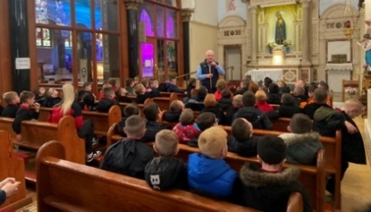
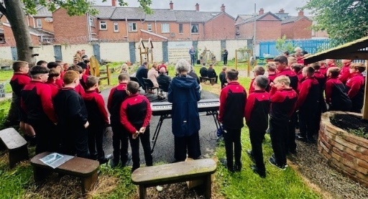
As Catholic teachers we try to cultivate and enhance human values, by the teachings and example of Jesus Christ. Our purpose is to help and bring pupils to an understanding of God’s creation and Christ’s vocation and ministry in the service of God and Man. Through the celebration of the sacraments and the partnership between staff, pupils, home and the local Church, our aim is to prepare our children for their relationship with the wider community and society. Through The Grow In Love, Alive-O and The Wonder of my Being Education Programme, we aim to develop pupils’ awareness of the dignity and sacredness of life, and that we are all unique and one with God the Father.

The Role of Religious Education in the Curriculum
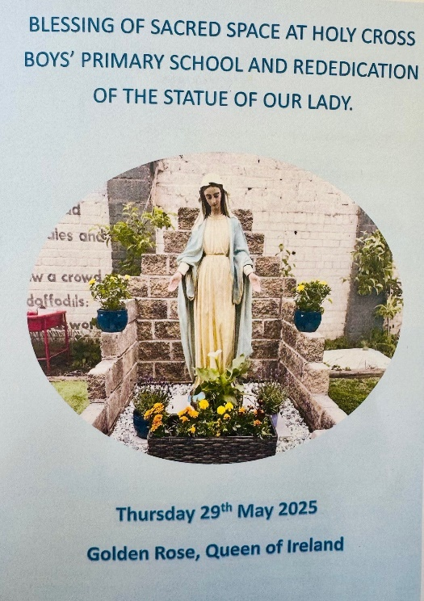
During their years at school, pupils will be introduced to different forms of prayer, through participation in the Liturgies and penitential services throughout the school year. This includes personal and communal prayer, and this will be central to the pupils’ lives and is an integral part of the school. Each class will take part in regular prayer services in class and prayer will take different forms such as singing and instrumental, meditative and contemplative.
The School Chaplain, Fr. Charlie Cross plays a prominent role within our school. Regular visits are made to each class, especially P3 – First Confession Year, P4- First Holy Communion, and P7- Confirmation and Final Year Mass.
First Confession for the pupils is during the Lenten season with the school choir participating to enhance the Liturgies. Penitential Services and individual confessions take place from P4 - P7.
The Grow in Love religious education programme is up and running from P1 – P7. This programme covers all of the theological, dogmatic and doctrinal material deemed appropriate for children of primary school age.

*Under article 21(5) of the Education and Libraries (NI) order 1986, parents have the right to withdraw their child from all or part of collective worship and/or RE lessons. Regulation 6 and Schedule 3 of the Education (School Information and Prospectuses) Regulations (NI) 2003 (SR 2003 No.378) requires schools to publish information in their prospectuses about RE provided at the school and any arrangements for the exercise by parents of their rights of withdrawal. Therefore, if a parent contacts the school and requests this, then this withdrawal will be granted.
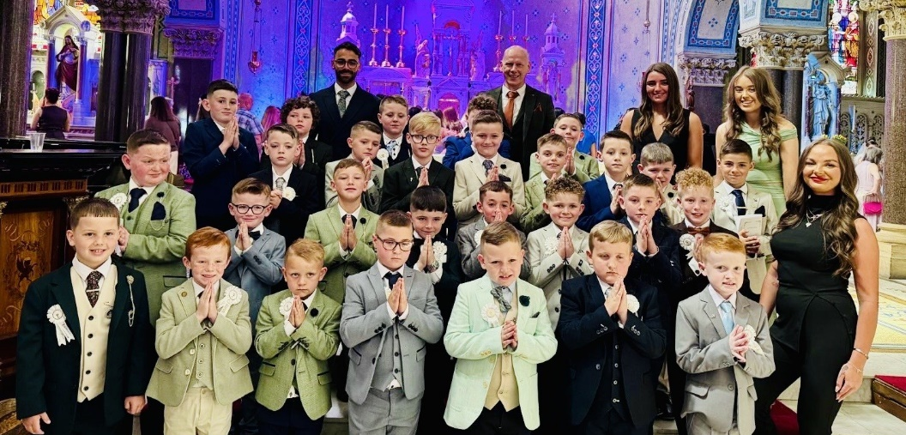
First Holy Communion YEAR 4

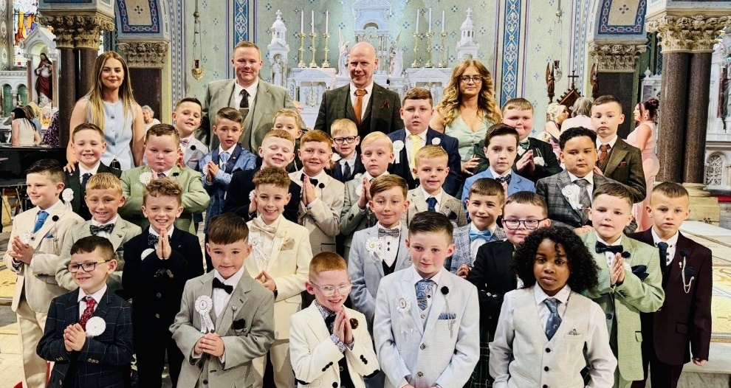

Sacrament of Confirmation YEAR 7

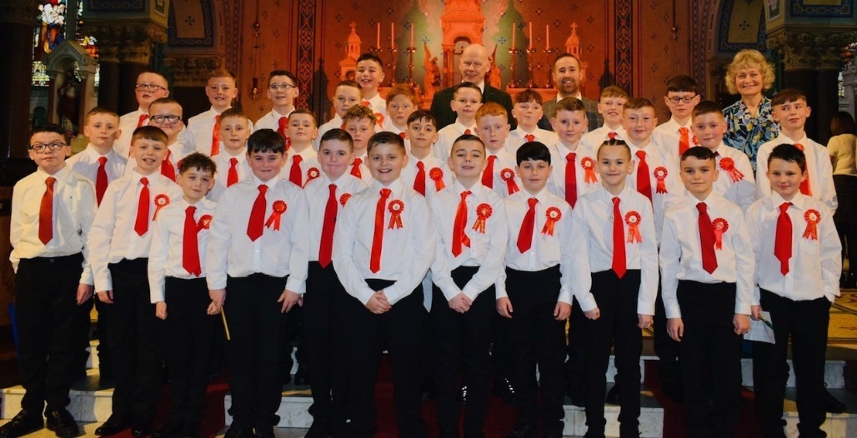
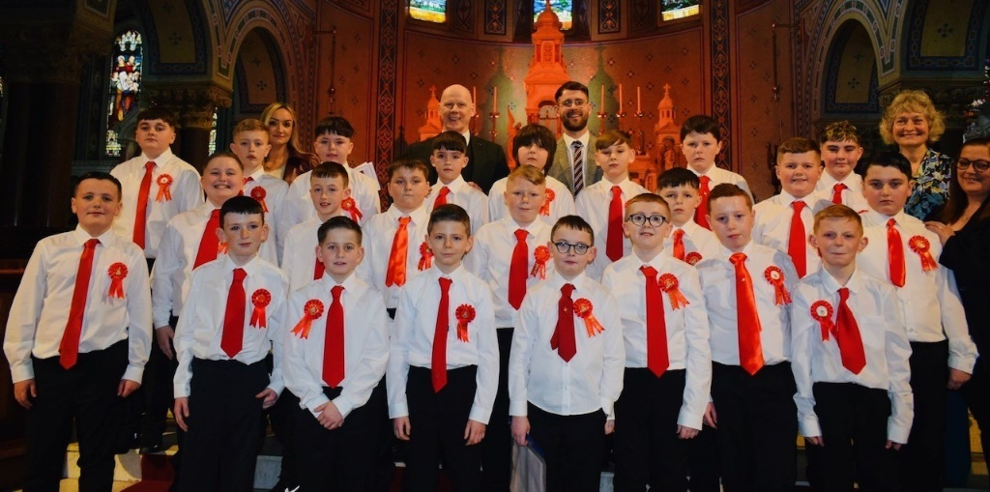
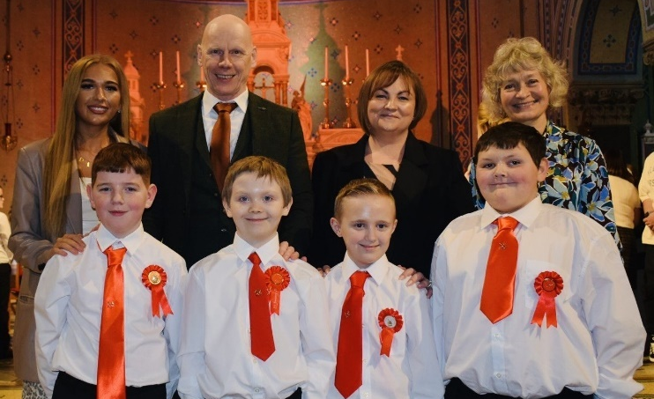

PASTORAL CARE
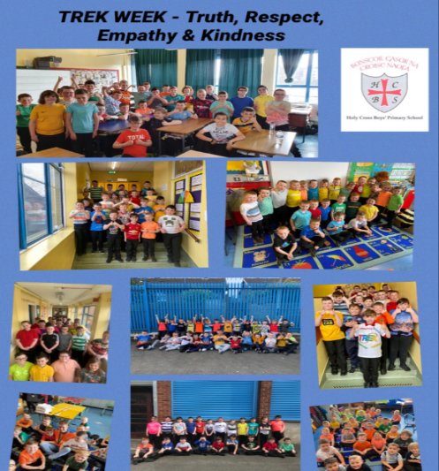
At Holy Cross Boys’ Primary School pastoral care permeates all aspects of school life. It reflects the values, attitudes, beliefs and practices of our Catholic faith and involves all members of our school community – children, parents and all other adults who contribute to the well-being of each child.
We strive to create an atmosphere where God’s love is experienced by all members of the school community through their relationships with each other, where Christ is the example to all and where each child is helped to develop to his full potential.
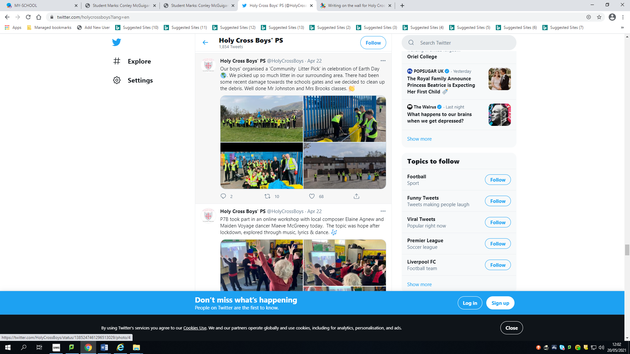
This atmosphere is based upon good relationships between staff/pupils/parents. As a staff we work as a team, respecting each other’s roles and recognising individual talents and expertise. We recognise and value the important role which parents play in their child’s education.
Every effort is made to ensure that parents feel welcome, that they are made aware of the school’s aims, objectives and policies and of their child’s individual needs, progress and achievements. We expect our parents to co-operate fully with us in achieving these goals.

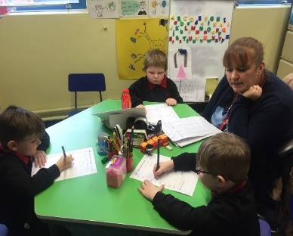
Special Educational Needs (SEN)
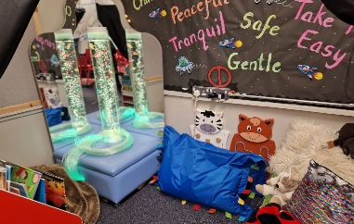
Special Educational Needs is given high priority in Holy Cross Boys’ Primary School. We are committed to the removal of any barriers that may inhibit learning or achievement. We liaise closely with all our pre-school settings to ensure the early identification of children with special educational needs. The special educational needs co-ordinator offers advice and guidance to the class teacher and, where appropriate, will arrange additional intensive learning support within a small group setting or on an individual basis. Parents are kept fully informed throughout this process. In Holy Cross Boys’ we provide a continuum of provision to assist us in meeting the diverse needs of all our pupils. This includes working closely with the Educational Psychology Service, RISE NI Team, Autism Advisory and Intervention Service and EA Outreach services (including Clarawood and Harberton Behaviour Support Outreach Teams, Peripatetic Literacy Service, St Gerard’s Literacy Outreach Support, Early Years Intervention Support Service, Language and Communication Service etc.) and various Health Agencies to maximise and secure high quality provision and to ensure the needs of our pupils are being addressed.
We have 3 SPiMS within Holy Cross Boys’ called The Rainbow Room, Moonlight Room and the Starlight Room. We also have 3 Sensory / Breakout Rooms that all pupils can have access to throughout the day.
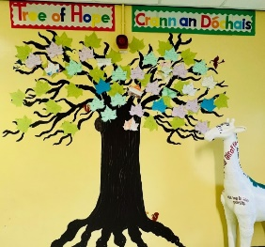
CHILD PROTECTION
We in Holy Cross Boy’s Primary School have a responsibility for the care, welfare and safety of the pupils in our charge. Through our pastoral care dimension, we aim to provide a safe, caring and supportive environment, where our pupils can learn and develop the confidence, they need to protect themselves from unwelcome behaviour or abuse from others, and to keep themselves safe.
All our staff and volunteers have had appropriate background checks and abide by the code of conduct agreed by the school. All those working in the school have received appropriate training and have the children’s safety and welfare as their main consideration at all times.
A Community School
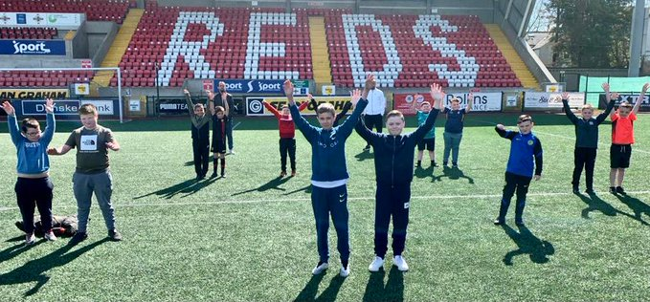
We are proud of our strong roots within the local Ardoyne community. We have fostered enduring relationships with local residents, youth and community groups, including Ardoyne Community Centre, Ardoyne Youth club, Aunt Nellie’s Café as well as Cliftonville FC, meaning our monthly winners spend an afternoon on the hallowed turf of Solitude playing football.
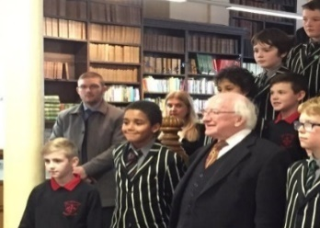
We have pro-actively moved to form partnerships with other schools to promote mutual understanding and to celebrate the arts, something that has been widely acknowledged, including by the President of Ireland, Michael D Higgins.

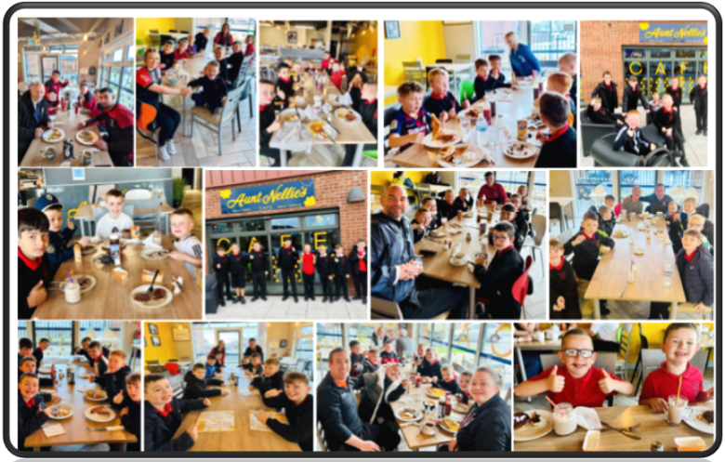

Wrap Around Care with Breakfast Club and After School Activities.

EXTENDED SCHOOLS
- Holy Cross Boys’ Primary School is at the hub of our local community, offering a wide range of activities before, during and beyond the traditional school day.
- We work alongside a range of external agencies to provide an extensive variety of activities for all year groups (Primary 1-7), parents and staff.

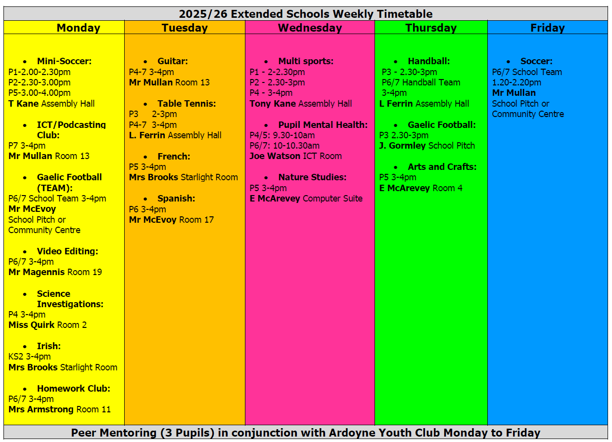

- We utilise specialist coaching from outside the school as well as expert teaching within the staff.
- Our weekly timetable offers excellent opportunities and experiences for our pupils and parents through four areas (Academic, Sporting, Parent and Community and Creative Arts).
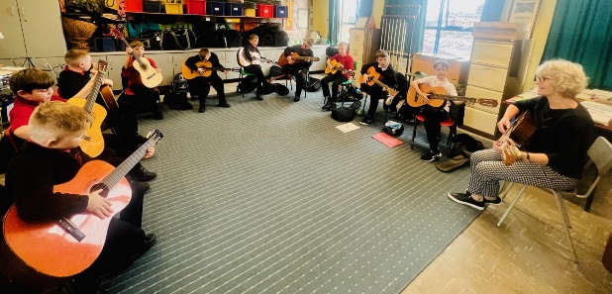
A range of other activities organised in the school, open to parents and the broader community, include:
- Philosophy for Parents Class
- First Aid-Parent Class
- NVQ Level 3 Childcare Course

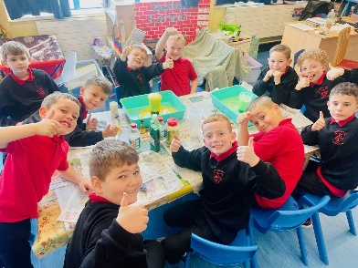
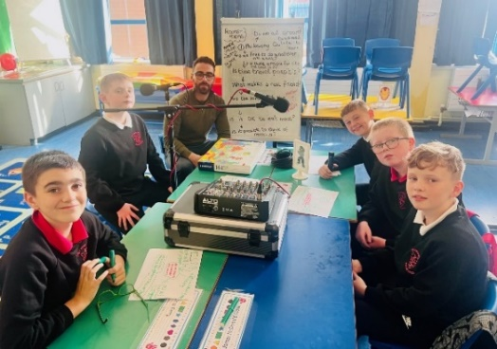
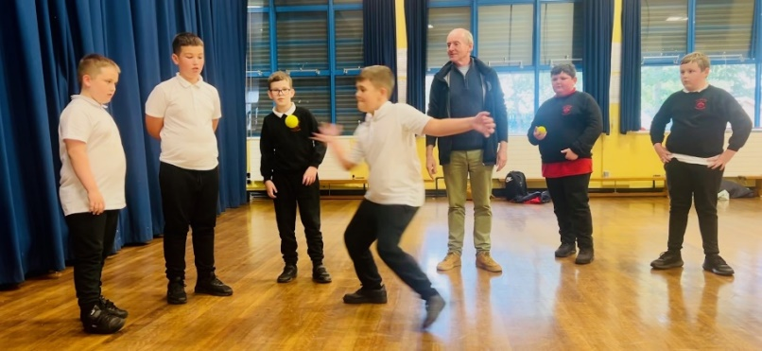
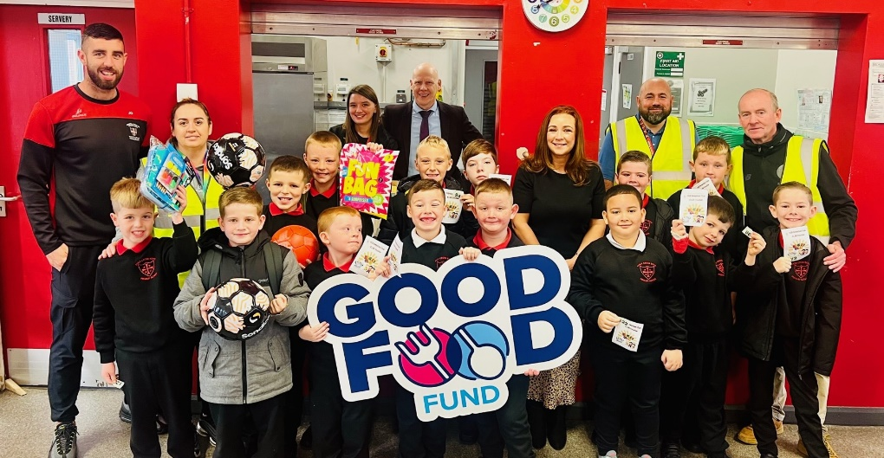
Breakfast Club opens at 8:00am in the school canteen from Monday to Friday and costs £1 per morning (includes cereal, toast and a drink).
Weekly Breakfast Club Winners
Anti-Bullying Ambassadors
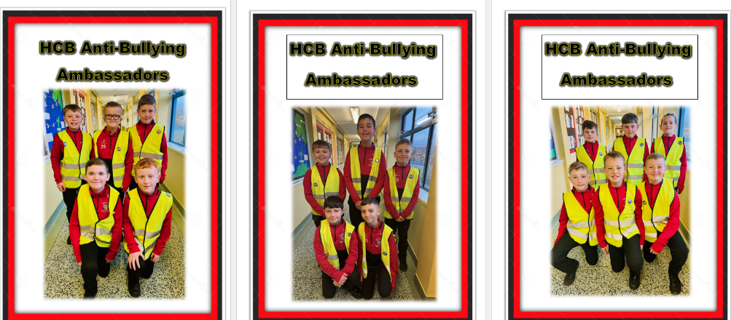
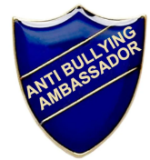
Everyone at HCB is fundamentally opposed to all forms of bullying. Every November, HCB organise many activities throughout Anti- Bullying Week to highlight this.
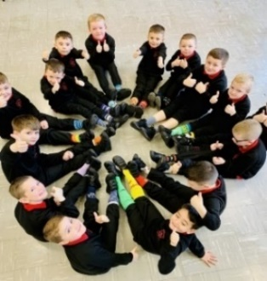
We celebrate Odd Socks Day to mark the beginning of Anti-Bullying Week, which is an opportunity to encourage people to express themselves and celebrate their individuality and what makes us all unique! To complete Anti-Bullying Week, the boys design a poster on the theme of anti-bullying.
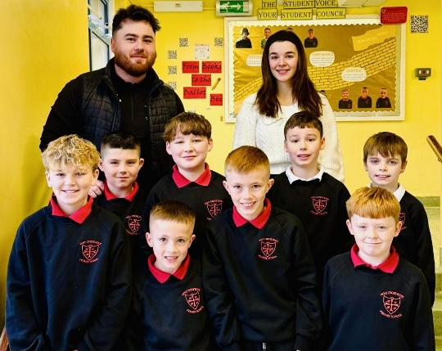
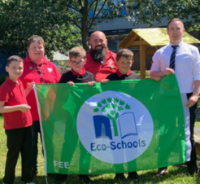
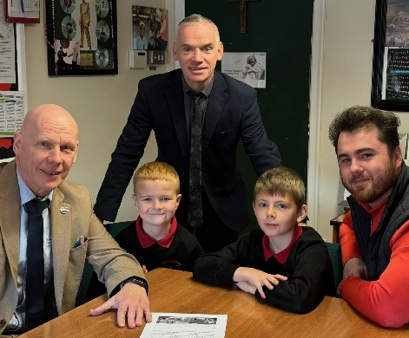
Our Year 7 pupils continue to be role models for our younger pupils and form part of our Anti-Bullying Ambassador Team. These boys help the supervisor in the Break and Lunch Zone for a particular Primary 1 to 3 class for one day each week. They help to ensure the Primary 1-3 pupils feel safe and have a friend to play with.

ECO Council for 2025-26
PUPIL VOICE: HCB Student Council for 2025-26
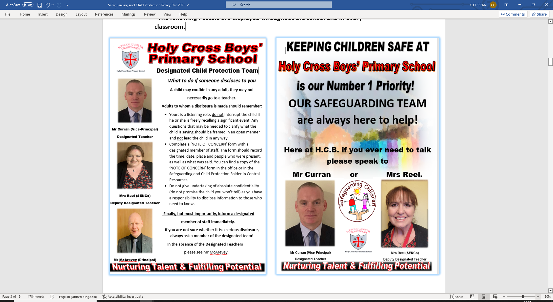
HCB is a safe and happy environment where pupils are motivated to learn. Meet our safeguarding Team.

Holy Cross Boys’ Primary School
K.S.1 Results for 2024/25
Key Stage 1 | W | Level 1 | Level 2 | Level 3
English | - | 3/58  5.4% | 42/58  72.6% | 13/58  22%
Maths | - | 3/58  5.1% | 43/58  74.2% | 12/58  20.7%

English L2+ = 94.8%
Maths L2+ = 94.8%

Holy Cross Boys’ Primary School
K.S.2 Results for 2024/25
Key Stage 2 | Level 2 | Level 3 | Level 4 | Level 5
English | 2/70  2.9% | 17/70  24.3% | 47/70  67.1% | 4/70  5.7%
Maths | 2/70  2.9% | 17/70  24.3% | 46/70  65.7% | 5/70  7.1%

English L4+ = 72.8%
Maths L4+ = 72.8%
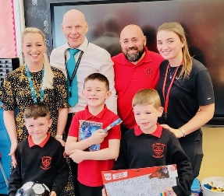
Rewarding our Pupils & Celebrating their Achievements
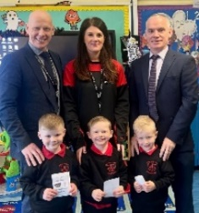
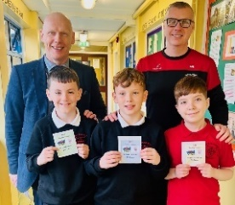
We make a huge effort each year to promote full attendance, and we monitor the attendance of all our pupils regularly. To motivate pupils, we give a Written Homework Pass for Thursday nights for pupils who attend school for all 5 days of the previous week. We pride ourselves on the high levels of attendance of our pupils, recognising that there is a correlation between pupil attendance and a child’s ability to realise his full academic potential.

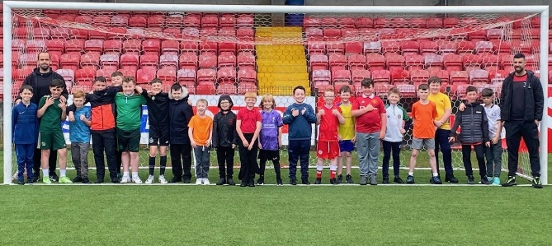
Solitude Weekly Winners: Twenty-six deserving Primary 4-7 pupils are selected for their outstanding efforts with their behaviour and attitude to visit Solitude on a weekly basis for a training session on the pitch with our staff members and local football stars, Joe Gormley (Cliftonville FC) & Tony Kane.
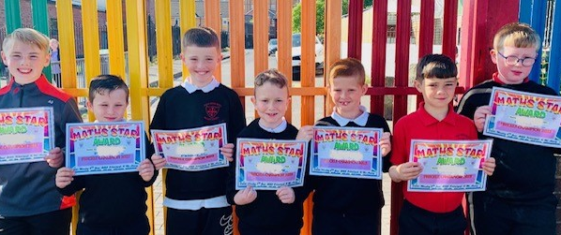
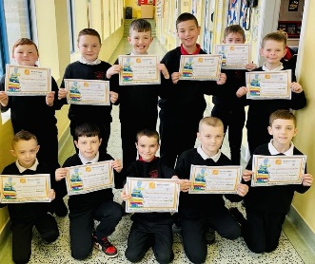
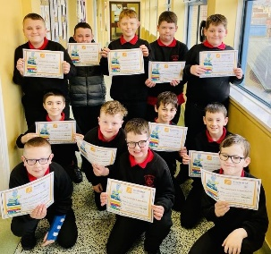
Accelerated Reader is a guided reading intervention used to supplement regular reading lessons within our P4 – P7 classes. Its aim is to improve students' reading skills through reading practice and quizzes on the books students read. The boys are rewarded regularly for their word counts and quiz accuracy and celebrated on our Accelerated Reader display wall for the rest of the school to see.
Freckle is a new online learning platform that allows our boys to practise Maths at their own level. Freckle then continuously adapts to each boy’s individual skills while ensuring they are getting the appropriate challenge. Each week, the boys who have been most accurate in their Freckle work are celebrated and are given the opportunity to try and guess the code of our Treasure Safe.

We have our Weekly Award Winners for best Reader, Mathematician, Sports Star, Musician, Artist, Healthy Eating Ambassador & Philosopher and also for following the School Rules - Listening, Learning, Treatment, Ready for School, Movement or Playground.
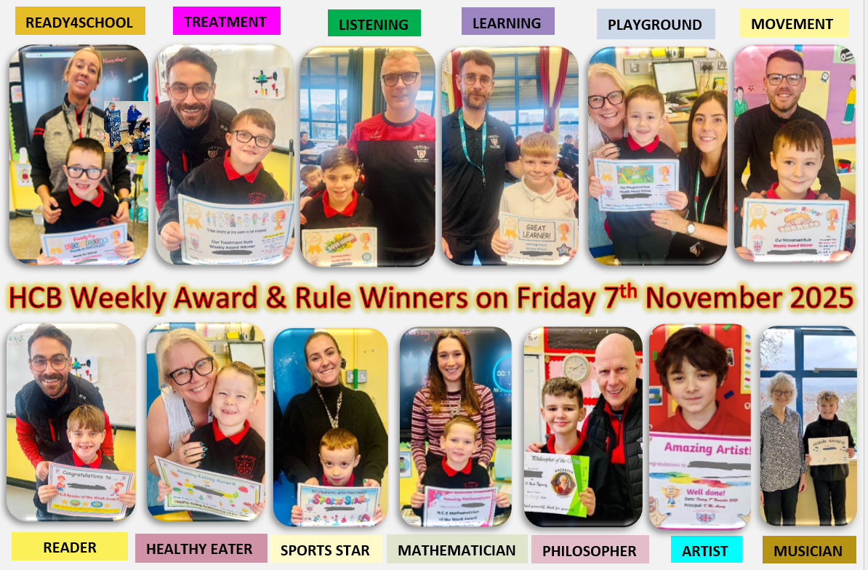

.
The boys all receive a special certificate and a tuckshop voucher!
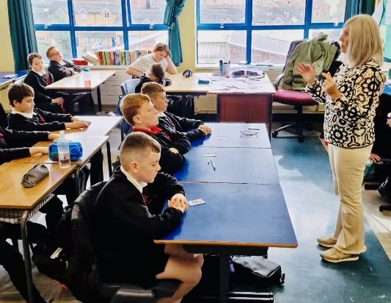
Mental Health & Wellbeing
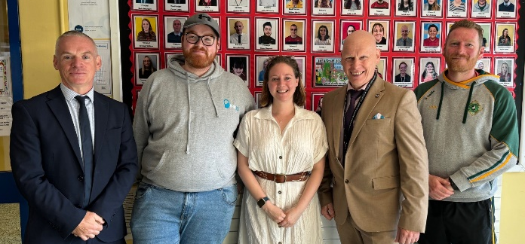
HCB celebrates World Mental Health Day (10th October) every year, with each class in the school experiencing a superb Aromatherapy and Relaxion session with Donna Hawkins from the Ardoyne Shankill Health Partnership. The boys love the Massage in Schools Programme, Take 5, which helps to improve mental health in schools. To complete the Mental Health and Wellbeing theme, we have our annual Mental Health Awareness Poster competition, which we share on our school website.
School Counselling in HCB: We provide counselling for 22 pupils on a weekly basis with Extended Schools funds (on Wednesdays) and we are delighted that Mental Health Movement (MHM) continues to provide a school counsellor (Stephanie) to work with our pupils (on Mondays & Tuesdays).

Classroom Assistants
Donna Connolly, Nuala Turley, Natasha Woods & Chloe Braniff. | Primary 1
Helen Laverty, Maureen Gouldie, Danielle Connolly & Brendan Madden. | Primary 2
Louise Quinn, Shannon Donnelly, Angela Stevenson, Aimee McKee, Danielle Connolly & Maura McCann. | Primary 3
Bridin McAreavey, Oisin Copeland & Christine Harrison. | Primary 4
Ciarna Wasson, Catriona Hunter, Caitlin Lagan, Alysha Porter, David McDonald, Steven Magennis & Maria McGonigle. | Primary 5
Sarah Graham. Sharon Cairns, Gearoid Frame, Dylan Donnelly & Denise McKenna. | Primary 6
Ciara Clarke, Emma Braniff &  Lewis Ridd. | Primary 7
Donna Clarke, Tony Kane, Hollie Mailey & Clodagh Carmichael. | (ASC)  Rainbow Room
Leonard Ferrin, Naomi Gormley & Angela Stevenson. | (ASC)  Moonlight Room
Erin McArevey, Joe Gormley & Tia Keenan, | (ASC)  Starlight Room
Natasha Woods | Nurture Room

Teaching Staff
Mr K McArevey | Principal
Mr C Curran | Vice Principal
Mrs Jan Marie Reel | SENCo
Mrs S Martin | Music Specialist
Mrs Flannigan | (ASC) Rainbow
Ms Lynch | (ASC) Moonlight
Mrs Brooks | (ASC) Starlight
Mr Joe Diamond | Learning Support
Miss Quirk | 1Q R2
Mrs Mohan | 1M R3
Mrs Fegan | 2F R4
Mrs McNeill/Mr Jennings | 2MJ R5
Mrs McShane | 3Mc R10
Mrs Armstrong | 3A R11
Mr Johnston | 4J R12
Mr Mullan | 4M R13
Mrs Wallace | 5W R14
Mrs Graham | 5G R15
Mr McEvoy | 6Mc R18
Mr Morrin | 6Mo R21
Mr Hawkins | 7H R20
Mr Magennis | 7M R19
Miss Graham & Mr Davey | Underachiever Programme

Meet The HCB Team 2025-2026

Ancillary Staff
Lorraine Gilbey | Caretaker
Cathy McConvey | Secretary
Harry McFadden | Lollipop Man
Bridghin Kerr | Lollipop Lady

HCB wins Best School Award at the Families First Education Awards
The End of The HCB Journey!

The School Community comes together with our Year 7 pupils & parents in June each year at a special Leavers’ Prize Giving Ceremony, to celebrate and highlight how every boy has fulfilled his potential during his 7 years at HCB.
